



3D Printing Injection Molding Metal Die Casting CNC Machining Other

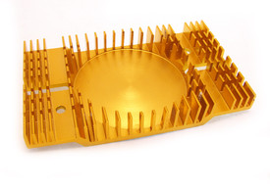

Plastic Injection molded parts and mold tooling

Molded parts.

Full range from small, tight tolerance parts to large industrial parts.

Mold tooling.

Supply of mold tooling for you run.

Prototype molds, bridge tooling, and full production molds

Single cavity, multi-cavity, unscrewing, hot runner,

Injection molding image

Why search the world for your custom parts, and tooling, when you can source them all right here

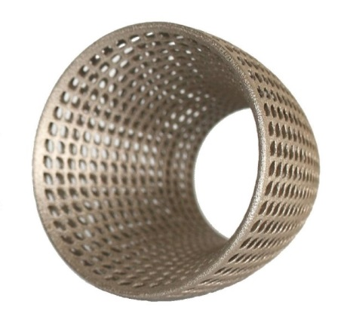

3D Printed and Advance Manufactured Parts

Plastic prototypes and parts SLA, SLS, FDM,

Metal parts. Aluminum, Steel, Cobalt Chrome, Titanium, Inconel, Maraging Steel

Make It Global.

Let us quote your project to supply your custom parts.

Fast, high quality and the lowest prices

Or let us help you find a supplier in the country or region you want.

3D printing image



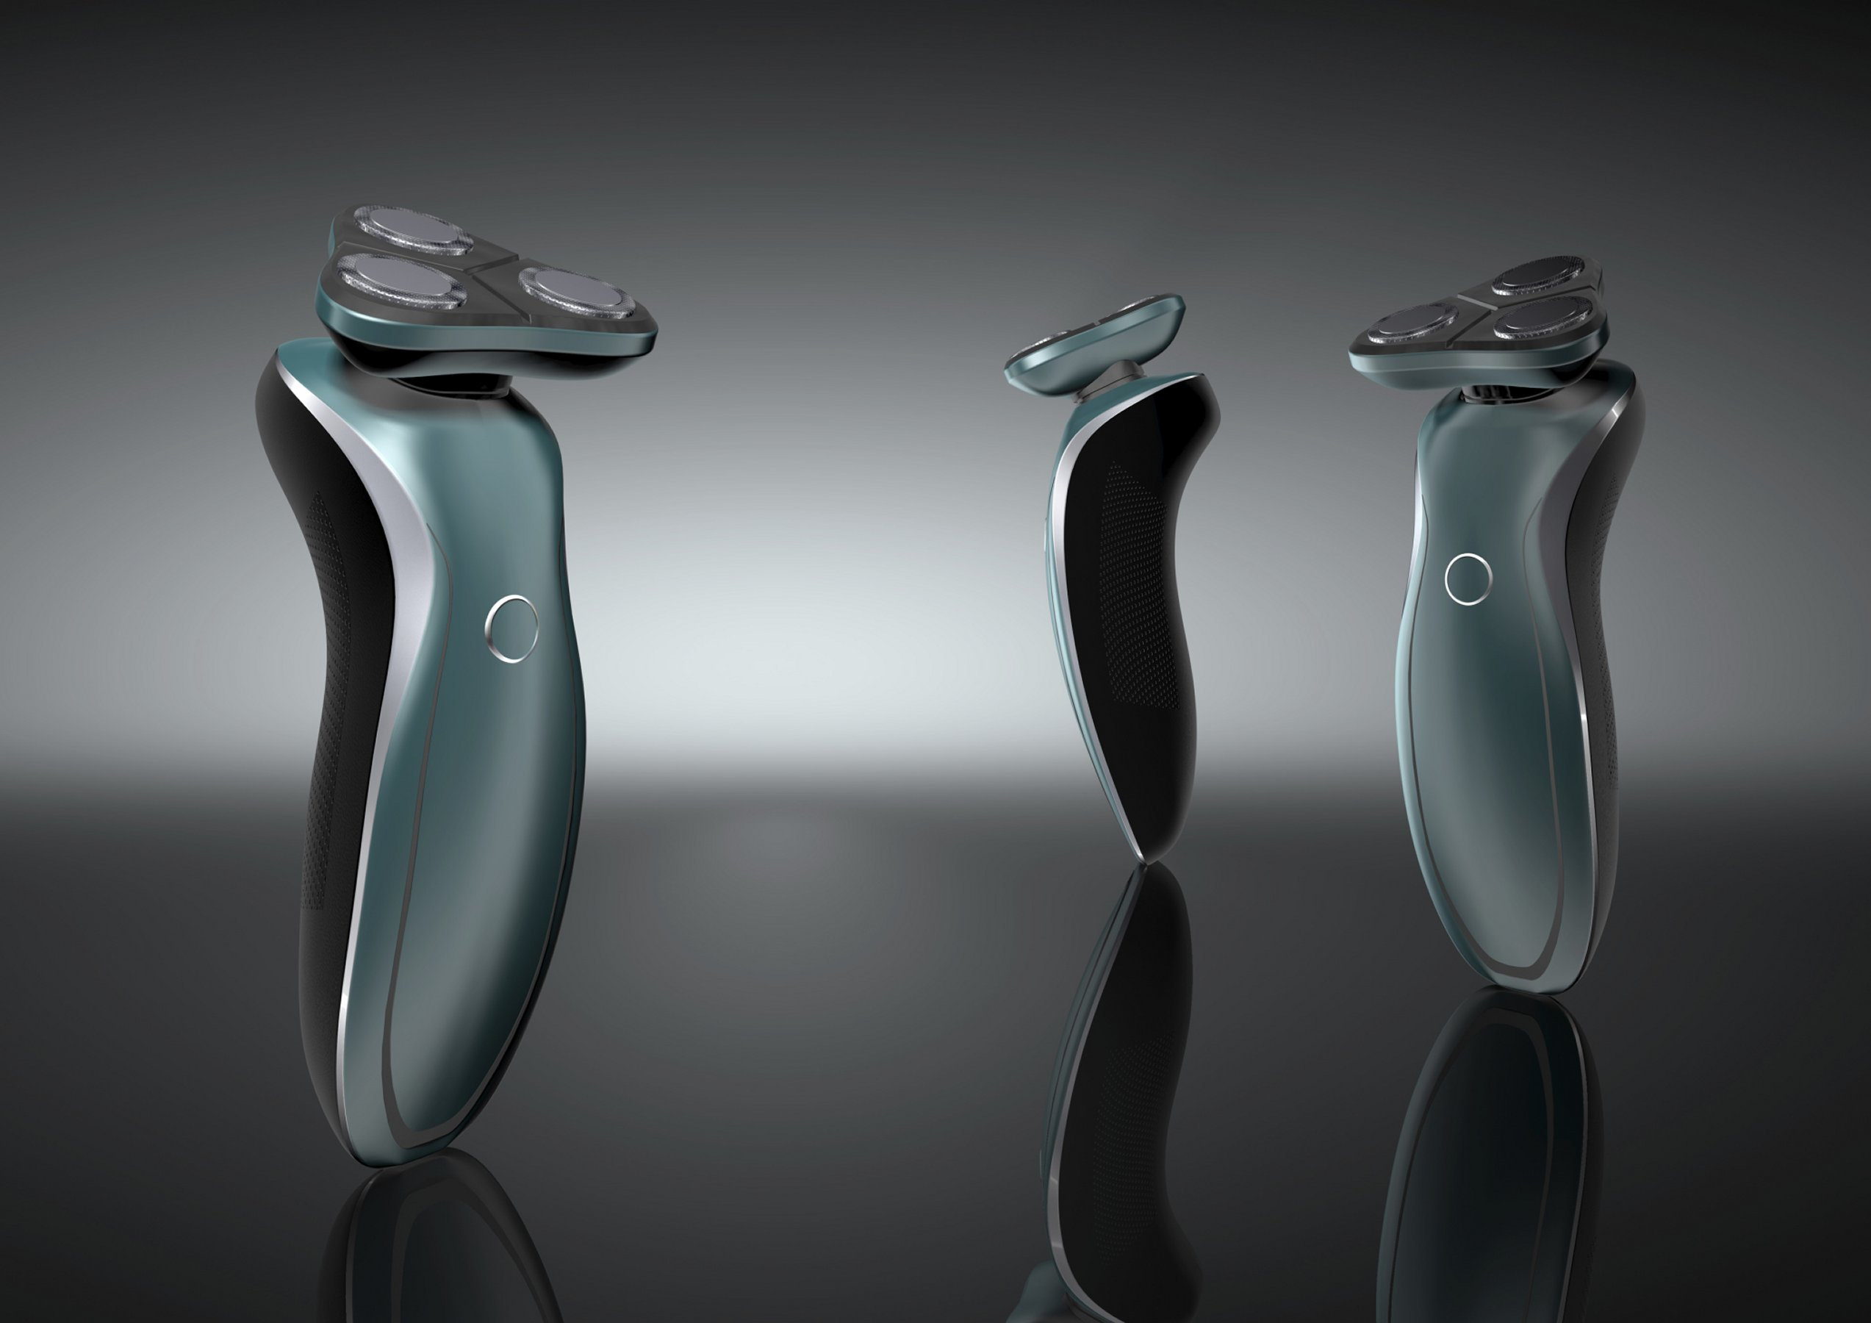

Contact / Get a quote

Other processes and parts

For Plastic parts - Compression molding, Rotational molding, Blow molding, Thermoforming.

For metal parts - Sheet metal fabrication, Stamping, Metal Injection molding, Forging, Springs and wire work.

Jig and Fixtures.

Carbon Composite and Ceramic parts

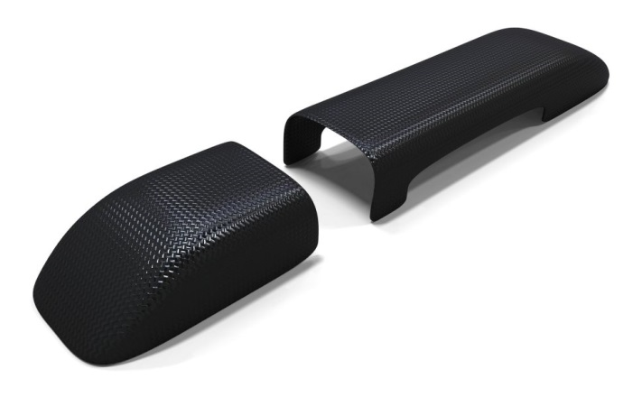

Other processes image

Other processes

Precision machining

Metal Die Casting

3D Printing

Plastic Injection molding

Find out more

Metal Die Casting

High quality, low volume and full production Die casting.

Secondary operations – machining and painting.

Materials include Aluminum, Zinc and Magnesium

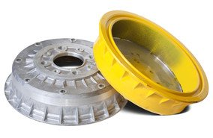

Die cast image

Precision machined parts

Plastics and Metals – Wide range of materials

CNC -3 - 4 and 5 axis, Turning and milling

Prototype, Batch and high volume production



CNC machine Image